International Conference: Your title (2 lines max) | 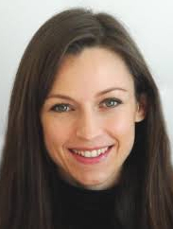
  Authors – Lastname, initials, Affiliation, Country (Gupta, S. K., Sharma, T. - Encapsol, France), on a single line

abstract
The current template must be used for preparing your contribution. Contributions that will not follow the guidelines will be sent back to the author.
To use the template: while this file is open, select « Display » then « Style » to open the style widow. In the menu menus list, select « Styles active in document ». We advise you to mask the “Ribbon”.
Do not include blank lines or paragraph indentations.
Text organisation
Your text must be sub-divided in the following sections:
Introduction & Objectives
Material & Methods
Results & Discussion
Conclusions & Perspectives
References
When applicable an acknowledgement section may be added at the end of the document.
You may subdivide the sections in subsections. These should be printed in italic and bold: Subsection
Tables
While possible use a figure instead of a table. Limit the number of rows and columns of your table. An example of a table is included below. Please use this as a template. Do not resize it. Copy and paste the table at the desired place in the text. You may add columns and rows to fit with your needs. Use the corresponding styles for the legend and for the header row. The header cells must have a 10% grey background.
Legend of table: should always be placed at the top
header | Alginate | Starch | PEG | Total
Cell 1
Cell 2

Figures
An example is included in this column for the desired format for figures or images. Figures are included in a table (1 column and 2 rows). Copy and paste this table at the right place in the text. Replace the figure in the top cell and change the text of the legend in the bottom cell. Do not modify the size neither the style of the table.
Figures are the attractive part of your contribution. It is advisable to use high quality, colourful images. The hardcopies of the proceedings are printed in high quality (600 dpi).
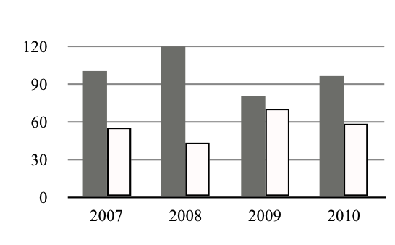
Legend of the figure: use this format. The figure can be replaced by a image or graph by simple dragging. Figure legends should be placed below the figure.
references
References in the text should be indicated by (Lastname of the first author, year of publication), (Scott, 2002). Do not use more than 5 references. Standard format styles can be found in any reference-formatting program. All authors should be included in the reference list unless there are five or more, in which case only the first 3 authors should be given, followed by 'et al.'. Authors must be listed by Lastname first, followed by a comma, and initials (followed by full stops) of given names. Book titles should be given in italics and all words in the title should have initial capitals. Journal names are italicized and abbreviated (with full stops) according to common usage. Volume numbers and the subsequent comma appear in bold. The full-page range should be given, where appropriate.
Published papers:
- Schott, D. H., Collins, R. N. & Bretscher, A. Secretory vesicle transport velocity in living cells depends on the myosin V lever arm length. J. Cell Biol. 156, 35-39 (2002).

Books:
- Smith, J. Syntax of referencing in How to reference books (ed. Smith, S.) 180-181 (Macmillan, 2013).
- Jones, H. in How to reference books 2nd edn, Vol. 4 (eds Brown, R. et al.) Ch. 8, 222-223 (Macmillan, 2014).

Website:
- Buckley, M. and Reid, A., Global food safety - keeping food safe from farm to table. Technical report. (2010) Available at: insert website here. (Accessed: 4th November 2012).

Acknowledgement and Full address
You may add a section for acknowledgements and to provide additional addresses of co-authors).

Submision guideline
Before to submit
- Verify that you respect the authors’ instructions
- Select Tools > Langue > English and verify any text underlined in red or green.
- Verify the size of your file (maximum 2 Mbytes). Be aware that reducing the size of images directly in word does not reduce the weight of the image. We advise to both reduce images in graph software, and select in word File > file size reduction
- Print your text on good color printer to see the quality and lisibility. Title of the paper should be in times new roman wh font size 14 bold.
- All the main headings should be in font size of 12 in bold whereas the subheadings should be in font size of 12.
Submit your contribution as a .docx file through the website as camera ready document. Do not send it as PDF file.

